**VISVESVARAYA TECHNOLOGICAL UNIVERSITY**

**BELGAUM**



A Mini Project report on

**“KAADU – The Wildlife Sighting and Booking Management”**

submitted in partial fulfilment of curriculum prescribed for the Database Management Systems (18CSL58) course for the award of the degree of

**BACHELOR OF ENGINEERING**

**IN**

**COMPUTER SCIENCE AND ENGINEERING**

by

**ADHNAN MANZIS ANIRUDDH G S**

**1AT18CS004 1AT18CS013**

Under the guidance of

**Prof. RAJENDRA M**

Associate Professor

Department of Computer Science & Engineering



**Anandnagar, Hebbal, Bengaluru - 560024**

**ATRIA INSTITUTE OF TECHNOLOGY**

**Anandnagar, Hebbal, Bengaluru – 560024**



**CERTIFICATE**

This is to certify that the project entitled **“KAADU – The Wildlife Sighting and Booking Management”** has been successfully completed by

**ADHNAN MANZIS ANIRUDDH G S**

**1AT18CS004 1AT18CS013**

in partial fulfilment for the Database Management System Laboratory with mini project report [18CSL58] – V semester, Bachelor of Engineering in Computer Science and Engineering during the academic year 2020-2021**.**

**Signature of Guide Signature of HOD**

**Mr. Rajendra M**  **Dr Aishwarya P**

Associate Professor

Department of CS & E

Name of the examiners

**DECLARATION**

We **Adhnan Manzis and Aniruddh.G.S,** students of 5th Semester B.E, Computer Science and Engineering at **Atria Institute of Technology, Bengaluru** hereby declare that the project work entitled **“KAADU – The Wildlife Sighting and booking management**” has been carried out by us as a part of the course work 18CSL58 - Database Management System under the supervision of **Mr. Rajendra M**, Associate Professor, Department of Computer Science and Engineering, Visvesvaraya Technological University, Belagavi during the academic year 2020-2021. We further declare that the report has not been submitted to any other university for the award of any other degree.

**Place: Bengaluru**

**Date:**

**ACKNOWLEDGEMENT**

We consider it as our privilege to express the gratitude to all those who guided us in the completion of the project.

We express my gratitude to Principal, Dr.T.N.Srinisvasa, for having provided us the golden opportunity to undertake this project work in their esteemed organization.

We sincerely thank Dr. Aishwarya P, HOD, Department of Computer Science and Engineering, Atria Institute of Technology for the immense support given to us.

We express our gratitude to our project guide Mr. Rajendra M, Associate Professor, Department of Computer Science and Engineering, Atria Institute of Technology for their support, guidance and suggestions throughout the project work.

At last, thanks to our parents and friends for their support.

Adhnan Manzis

Aniruddh.G.S

Abstract

**Index/Contents**

1. **Introduction**
   1. Identification
   2. Purpose
   3. Scope
   4. Definitions, Acronyms, and Abbreviations
   5. References
   6. Overview and Restriction
2. **Description**
   1. Product Perspective
   2. Product Features
   3. User Classes and Characteristics
   4. Operating Environment
3. **Requirements**
   1. Expected/General requirement
   2. Normal/Naturalist requirement
   3. Exciting/Tourist requirement
4. **External Interface Requirements**
   1. User Interfaces
   2. Hardware Interfaces
   3. Software Interfaces
   4. Communication Interfaces
5. **Non-functional Requirements**
   1. Safety Requirements
   2. Security Requirements
   3. Software Quality Attributes
6. **System Design**
   1. Tourist
   2. Naturalist
   3. Administrator
   4. Class Diagram
   5. ER diagram
   6. Schema Diagram
7. **Modules in the system**
   1. Homepage
      1. Tourist Sign-up
      2. Naturalist Sign-up
      3. Login Page
      4. Welcome Page
      5. Naturalists
      6. Contact Us

* 1. Tourist
     1. Login Page
     2. Home page
     3. Profile
     4. Sightings
     5. Booking
     6. Update Password
     7. Sign Out
  2. Naturalist
     1. Login Page
     2. Homepage
     3. Sightings
     4. Add A New Sighting
     5. Update Password
     6. Sign Out

1. **Screenshots of the implemented system**
2. **Conclusion**
3. **References**

**CLASS DIAGRAM**

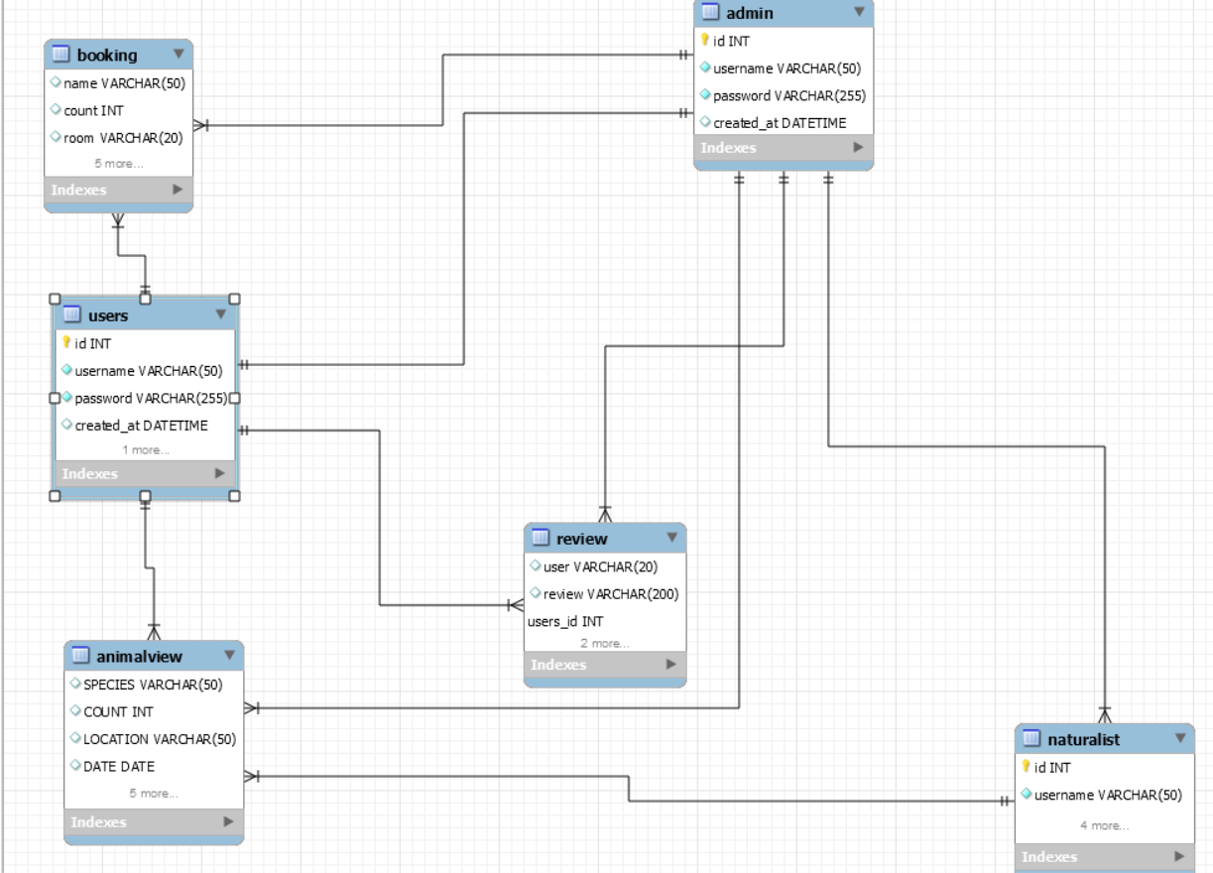

**ER DIAGRAM**

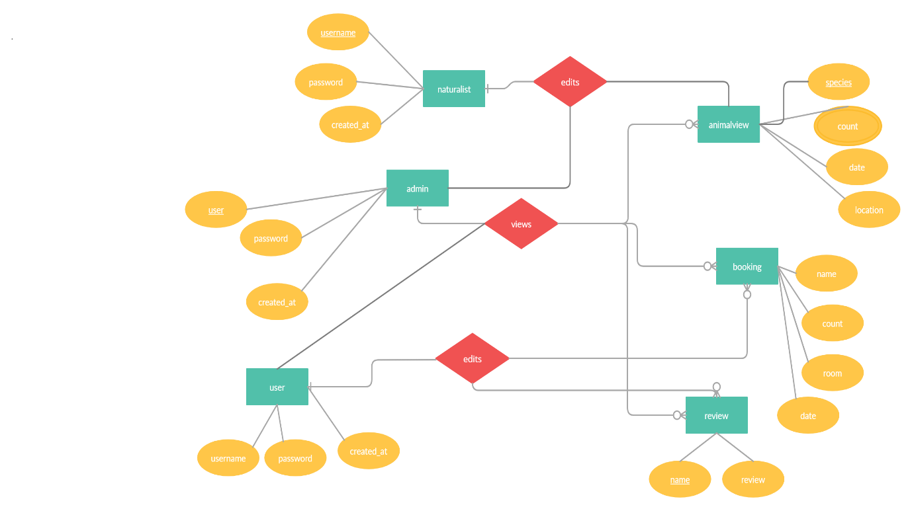

1. **INTRODUCTION**
   1. **Identification**
   2. **Purpose**
   3. **Scope**
   4. **Definitions, Acronyms, And Abbreviations**
   5. **References**
   6. **Overview and Restriction**
2. **DESCRIPTION**
   1. **Product Perspective**
   2. **Product Features**

* User can be an naturalist or a tourist.
* The terms to use the application is available.
* Naturalist can register to the portal by the entering the details.
* Naturalist can login through their credentials.
* Naturalist can create add new sighting.
* Naturalist can update their password.
* Tourist can register to the portal by providing the details.
* Tourist can login through their credentials.
* Tourists can view the home page.
* Tourists can view sightings in the home page.
* Tourists can book rooms for stay.
* Tourist can confirm booking .
* Tourists can share their reviews and experience.
* Tourists can update and reset password.
* Administrator can view Tourists.
* Administrator can view Naturalists.
* Administrator can view Sightings.
* Administrator can view bookings.
* Administrator can view Tourist shared experiences.
  1. **User Classes and Characteristics**

There are several types of end users for KAADU – The Wildlife Sighting and Booking management. They can be classified as Tourists, Naturalists and Administrator.

The Tourist has access to the following features on the platform:

* View the sightings.
* Book a safari/stay .
* Share their experience.
* Update/reset their password.

The Naturalist has access to the following features on the platform:

* Add Sightings.
* View sightings.
* Reset Password

The administrator has access to the following features:

.

* View and delete all the tourists in the platform.
* View and delete all the Naturalists in the platform.
* View user and tourist reviews.
* View bookings
* View sightings added by naturalists.
* Add sightings .
* Update/reset password.
  1. **Operating Environment**

The operating environment for the KAADU application is listed below:

Operating System: Windows10

Database: MySQL

Front end: HTML, CSS, Bootstrap

Back end: PHP

1. **REQUIREMENTS**
   1. **Expected/General Requirement**

Naturalist and tourist information

Description: Information regarding tourists, naturalists, sightings and bookings are stored in the database. Every user can view only certain information based on their user class.

For example, an naturalist can view the information of sightings that they are handling. This feature is important as the information must be viewed by only the authorized users.

Functional requirements

* Each user shall be able to view information in the database based on their user class.
* The administrator shall be able to view all the information in the database.
  1. **Naturalist Requirement**

Creating an account and Add sightings.

Description: Adding sightings are bookings is the main feature of KAADU. Naturalists create and update the Sightings. Tourists can view their profile and sightings and also do bookings .

Functional requirements

• Naturalists shall be able to view and update the sightings.

• Naturalists can also update their passwords**.**

* 1. **Tourist Requirement**

Creating account, view sightings, book a safari or stay, and share reviews.

Description: Tourists can view all the sightings on the home page added by naturalists. They can book a safari or stay. Tourists can share reviews and experience.

Functional requirements

* + Tourists shall be able to view all sightings.
  + Tourist can update password.
  + Tourist can add booking for safari/room.

1. **EXTERNAL INTERFACE REQUIREMENTS**
   1. **User Interfaces**

The user interface is made using Bootstrap. We have a Home Page, an existing user can sign-in using their credentials and the new user can sign-up. There is separate page for naturalist and tourist sign-up. Each tourist and naturalist will have a unique interface.

* 1. **Hardware Interfaces**

Since neither the mobile application nor the web portal have any designated hardware, it does not have any direct hardware interfaces. Any browser can be used to access the webapp.

* 1. **Software Interfaces**

The following is the list of software used in making of the project:

* Operating System:

Windows operating system for its best support and user-friendliness.

* PHP:

PHP is used for the back-end of the website. It is a server scripting language which was used to connect MySQL with our website .

* Database:

We are using MySQL database .

* 1. **Communication Interfaces**

This project is to be deployed on an online website. All users can connect to the database server from anywhere and have access to their information.

1. **NON-FUNCTIONAL REQUIREMENTS**
   1. **Safety Requirements**

If there is an extensive damage to a wide portion of the database due to catastrophic failure. Such as a disk crash, the recovery method restores a past copy of the database that was backed up to archival storage (typically tape) and reconstructs a more current state by reapplying or redoing the operations of committed transactions from the backed-up log, up to the time of failure.

* 1. **Security Requirements**

The database contains sensitive information of all the tourists and naturalists. Therefore, optimal security measures must be taken to ensure data is safe from unauthorized users.

* 1. **Software Quality Attributes**

Availability:

The users must always be able to view their information so that they can keep track regularly.

Portability:

The users should be able to access the KAADU from various platforms such as desktops and mobile phones. The webapp must be portable to all platforms and the user experience must be optimal.

1. **SYSTEM DESIGN**

Various Design concepts and processes were applied to this project. Following concepts like separation of concerns, the software is divided into individual modules that are functionally independent and incorporates information hiding. The software is divided into 3 modules which are tourists, naturalists and administrators. We shall look at each module in detail.

* 1. **Tourist**

Tourist Profile/Information

Tourist Booking

* 1. **Naturalist**

Naturalist Profile/Information

Sightings added.

* 1. **Administrator**

The administrator will have access to all the information in the different tables in the database. They will access to all the tables in a list form. They will be able to add an entry in any table and also edit them. The design of the view for the admin will provide a modular interface so that querying the tables will be optimized. They will be provided with search and filter features so that they can access data efficiently.

* 1. **Class Diagram**

The class diagram states the different classes involved in the software. A class represent a concept which encapsulates state (attributes) and behaviour (methods). Each attribute has a type. Each operation has a signature. The + (public), - (private) and # (protected) symbols before an attribute and operation name in a class denote the visibility of the attribute and operation.

* 1. **Er Diagram**

An entity relationship diagram (ERD) shows the relationships of entity sets stored in a database. An entity in this context is an object, a component of data. An entity set is a collection of similar entities. These entities can have attributes that define its properties.

By defining the entities, their attributes, and showing the relationships between them, an ER diagram illustrates the logical structure of databases. ER diagrams are used to sketch out the design of a database.

* 1. **Schema Diagram**

A database schema defines its entities and the relationship among them. It contains a descriptive detail of the database, which can be depicted by means of schema diagrams.

1. **MODULES IN THE SYSTEM**

The KAADU has three main user classes. These include the tourists, naturalist and administrator. This section will explain in detail all the features and the working of those for each user class.

* 1. **Homepage**

This is the main page and has the following options and redirects the user to the other pages.

* + 1. **Tourist Sign-Up**

A new user – if a tourist, can register by providing the details that are asked and submitting it. After registering, the tourist can start using the portal by logging in with the appropriate credentials**.**

* + 1. **Naturalist Sign-Up**

A new user – if an naturalist, can register by providing the details that are asked and submitting it. After registering, the naturalist can start using the portal for creating course by logging in with appropriate credentials.

* + 1. **Login Page**

Each user can login by using the registered email and password. The username is same as email provided during registration. If the user doesn’t have an account then they can create one. The ‘Click Here’ option redirects the user to the page from where they can register.

* + 1. **Welcome Page**

Welcome page has the list of all sightings on our KAADU platform. Each sighting has details of the species, location and date when the sighting happened.

* + 1. **Naturalists**

This page has the list of all the naturalists who have added sightings on the portal with the details of each naturalist and the sightings they have uploaded

* + 1. **Contact Us**

This page has the contact details like email id, twitter account, contact numbers.

* 1. **Tourist** 
     1. **Login Page**

Tourist can login using their credentials, they are directed to homepage and a message appears informing successful log in.

* + 1. **Home Page**

After successful login, the tourist has the option to view about the national park.

* + 1. **Profile**

This page has the details of the tourist and list of the sightings .

* + 1. **Sightings**

This page has all the details of sightings uploaded by the Naturalists .

* + 1. **Booking**

Tourist can book a safari/ room and get confirmation of booking.

* + 1. **Update Password**

Tourist can update and reset password.

* + 1. **Sign Out**

Clicking on sign-out, logs you off from your account, displays a message confirming it and redirects you to home page.

* 1. **Naturalist**
     1. **Login Page**

Naturalist can login using their credentials, they are directed to homepage and a message appears informing successful log in.

* + 1. **Homepage**

Welcome page has the list of all sightings on our KAADU platform. Each sighting has details of the species, location and date when the sighting happened.

* + 1. **Sightings**

This page has the details of the naturalist and list of the sightings they have added. It has details like name of species, location and date when it happened.

* + 1. **Add A New Sighting**

This page allows the naturalist to add a new sighting by adding species name, location, number of animals and date when it was sighted.

* + 1. **Update password**

Naturalist can update and reset password.

* + 1. **Sign Out**

Clicking on sign-out, logs you off from your account, displays a message confirming it and redirects you to home page.

1. **SCREENSHOTS OF THE IMPLEMENTED SYSTEM**

* **Home Page**

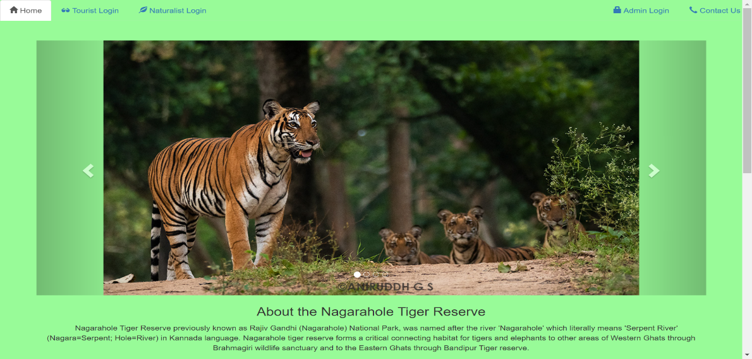

* **Common Pages**
* **Reset Your Password Page**

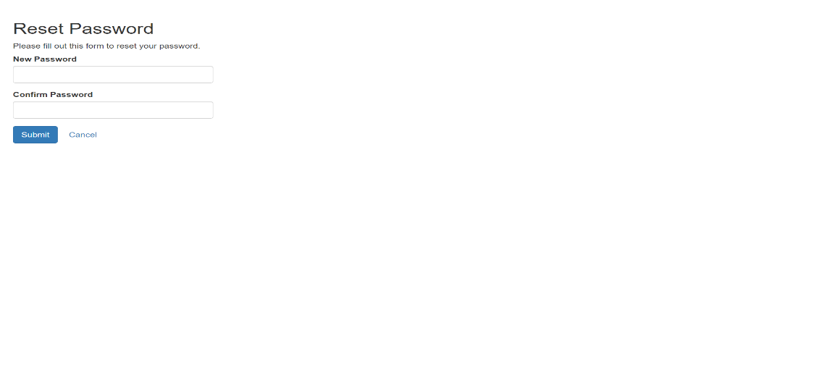

* **Welcome Page**

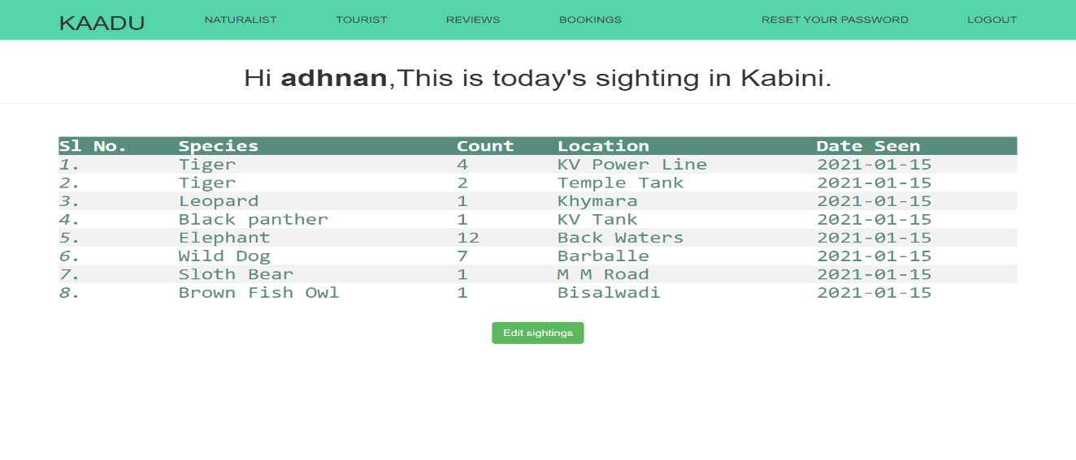

* **Tourist Exclusive Page**
* **Login Page**

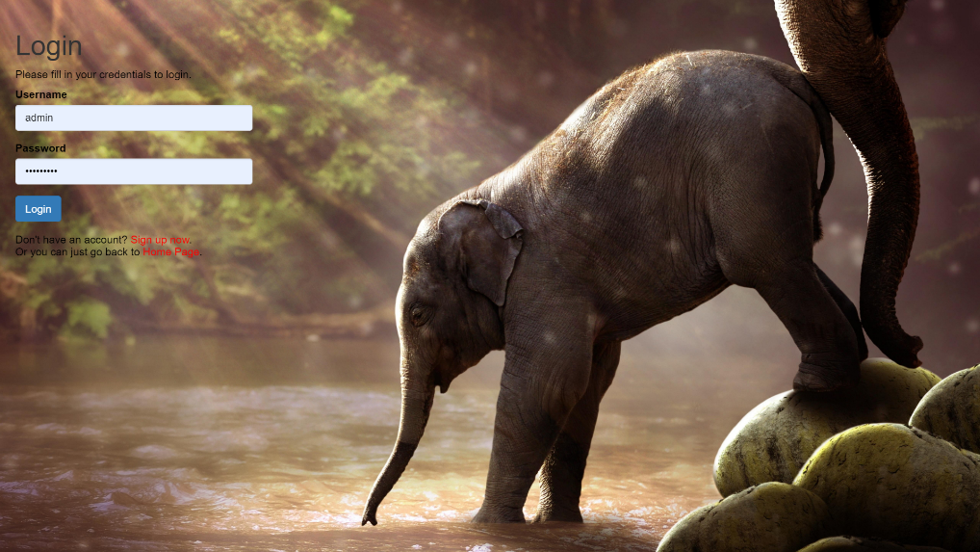

* **Booking Page**

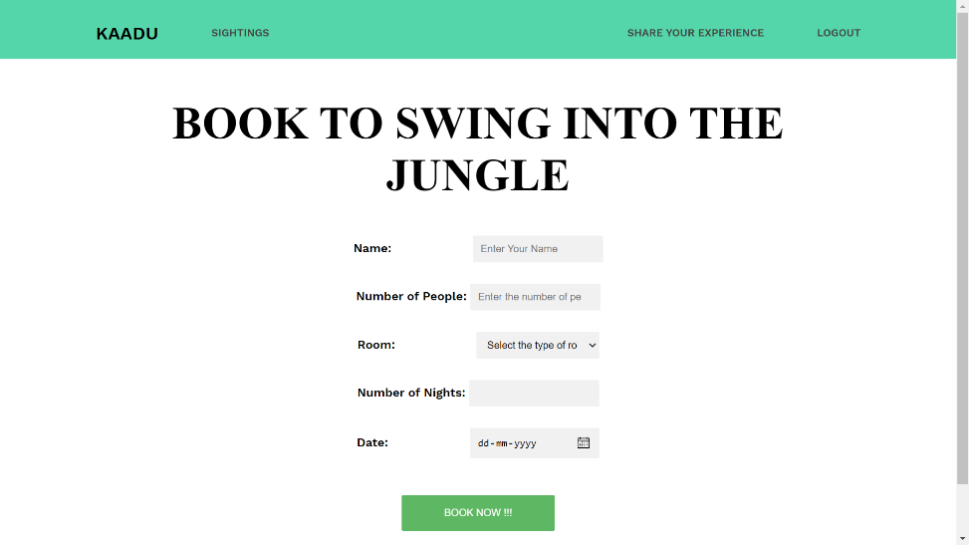

* **Share Your Experience Page**

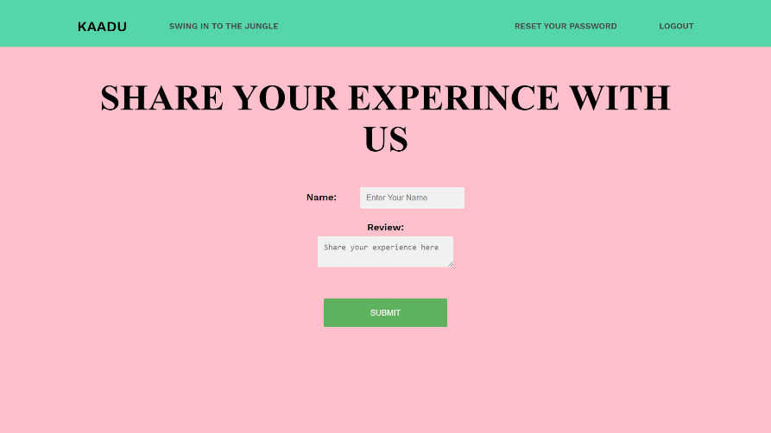

* **Naturalist Exclusive Page**
* **Login Page**

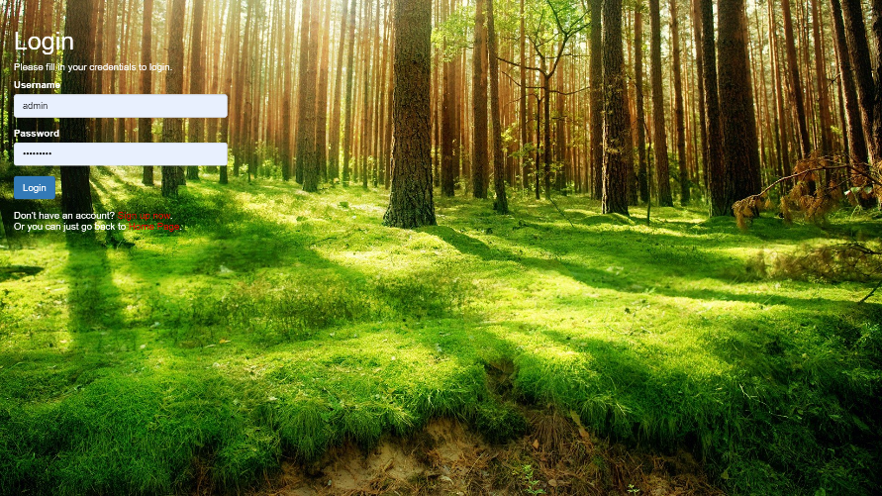

* **Add Sighting Page**

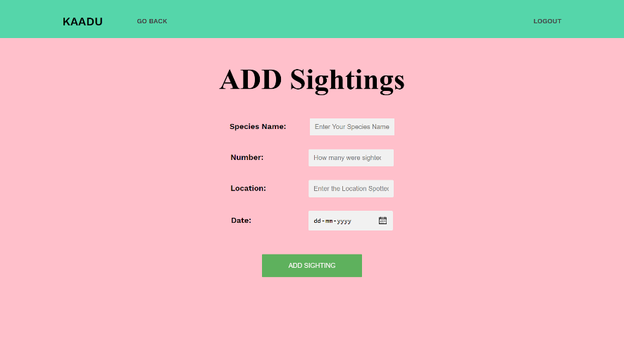

* **Admin Exclusive Page**
* **Login Page**

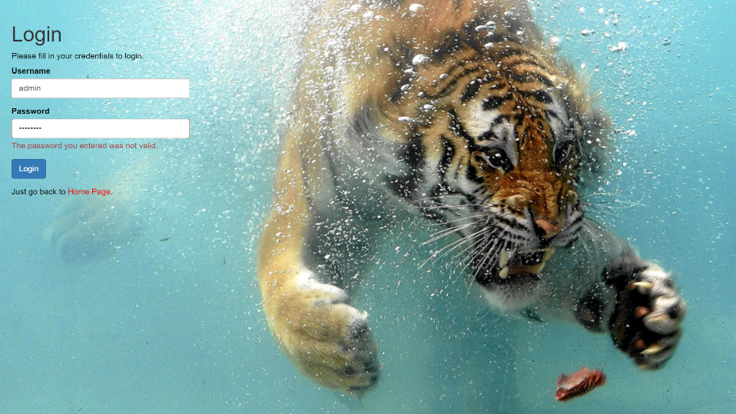

* **View Tourist Account page**

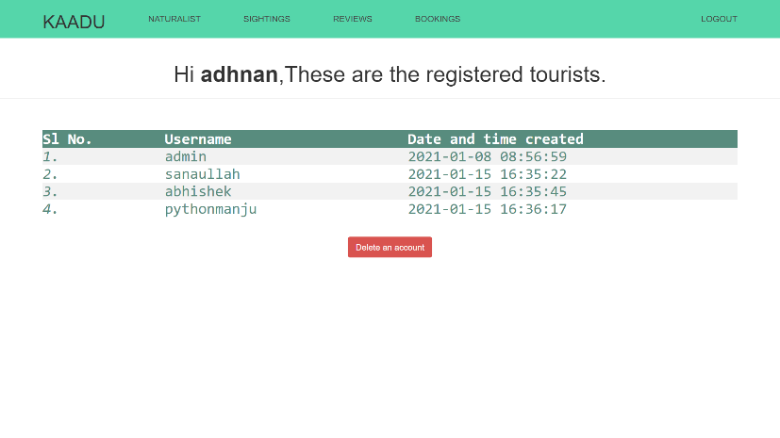

* **View Naturalist Account Page**

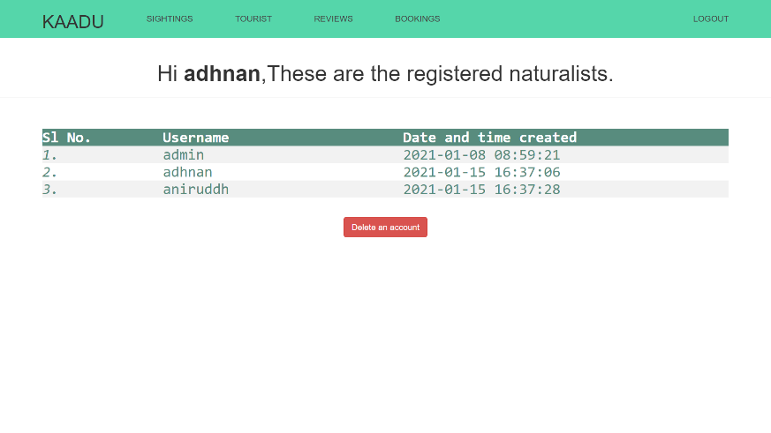

* **View Tourist Review Page**

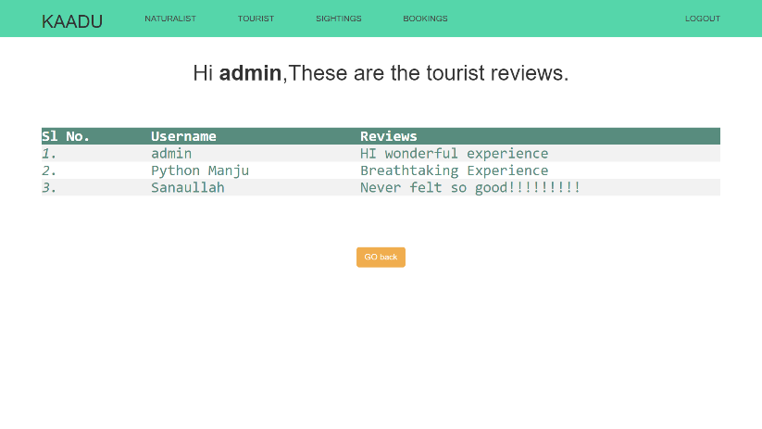

* **View Tourist Booking Page**

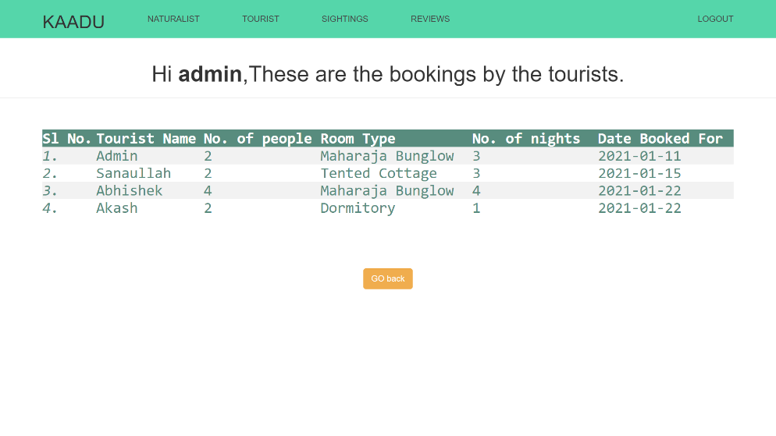

* **Delete Tourist Page**

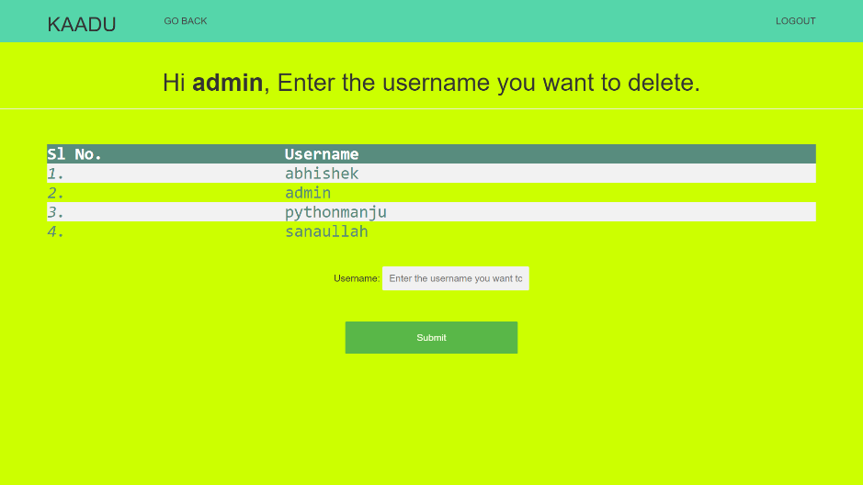

* **Delete Naturalist Page**

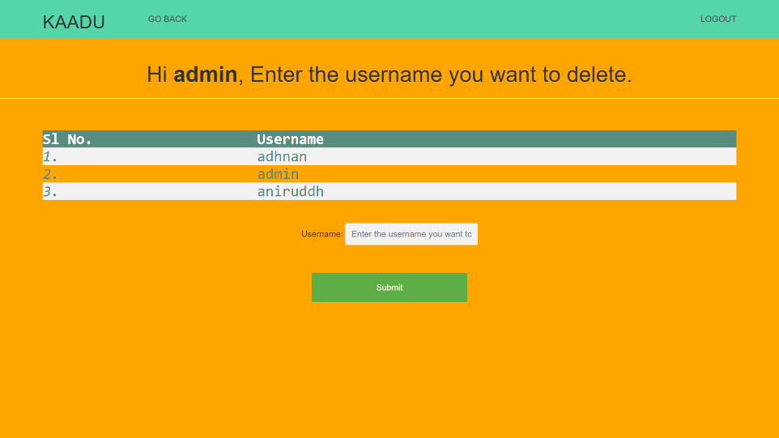

1. **CONCLUSION**

* KAADU - The Wildlife Sighting and Booking Management System automates the existing manual system of Pen-paper Wildlife Record management with the help of computerized equipment and full-fledged computer software, fulfilling their requirements so that their valuable data information can be stored for a longer period with easy accessing and manipulation of the same, especially during Census and Tracking of Wildlife. The required software and hardware are easily available and easy to work with.
* The Sighting Management system, as described above, leads to error-free, secure, reliable and fast management systems. It assists the Naturalist/Forest guard to enter the details of sightings for that particular day from anywhere and anytime. Thus, it helps the Forest Department to keep a better track of the animal sightings and this helps during Census and also curb illegal activities of smuggling and Poaching.
* The Forest Department along with the Resort can maintain computerized records without redundant entries. That means that one need not be distracted by information that is not relevant while being able to reach the information. Thus, their valuable data/information can be stored for a longer period with easy accessing and manipulation of the same.
* The Booking system helps the users to easily book a room for Safari, where they are given different choices of the types of rooms based on their budget/availability, and the same data can be used by the resort for allotting Safaris and keeping a record on the guests visiting.
* In a nutshell, it can be summarized that this project can be implemented on a larger scale, for the Benefit of The Karnataka Forest department, Government of Karnataka and can also be updated for the use in other national parks across the country for the Benefit, Welfare and better Census and protection of the majestic Wildlife of Our Nation.

1. **REFERENCES**

* Elmasri and Navathe: Fundamentals of Database Systems, 7th Edition, Pearson Education, 2016.
* Ian Sommerville: Software Engineering, 10th edition, Person Education Ltd, 2015.
* Roger S Pressman: Software Engineering- A Practitioners approach,8th edition, McGraw-Hill Publication, 2015.
* https://www.w3schools.com
* https://en.wikipedia.org/wiki/Requirements-engineering
* https://web.cs.dal.ca/ hawkey/3130/srs-template-ieee.doc
* http://www.ntu.edu.sg/home/cfcavallaro/Reports/Report%20writing.htmTop
* https://en.wikipedia.org/wiki/Class diagram
* https://getbootstrap.com/
* https://www.tutorialspoint.com/
* https://creately.com/
* https://www.overleaf.com/project